**SCREENSHOTS OF DIFFERENT YEAR SHEETS OF STOCK DATA ANALYSIS**

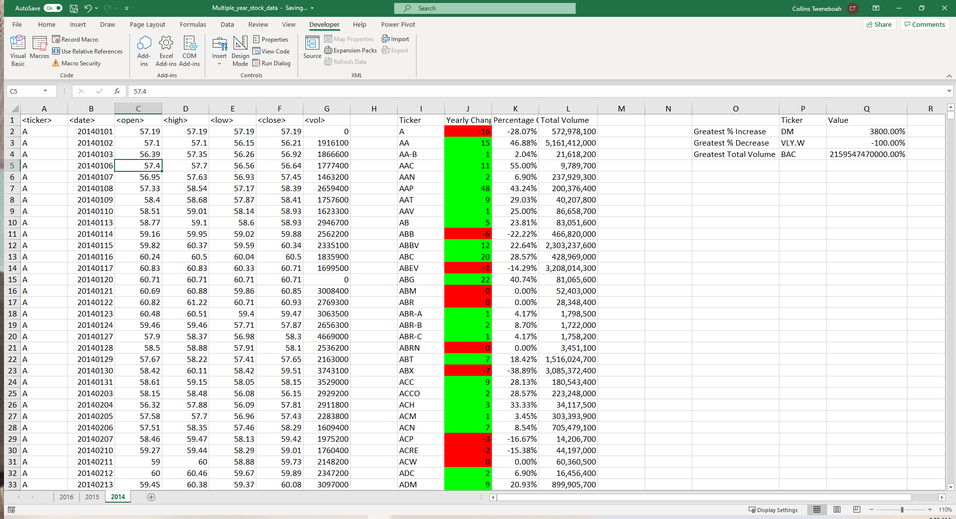

Worksheet 2014

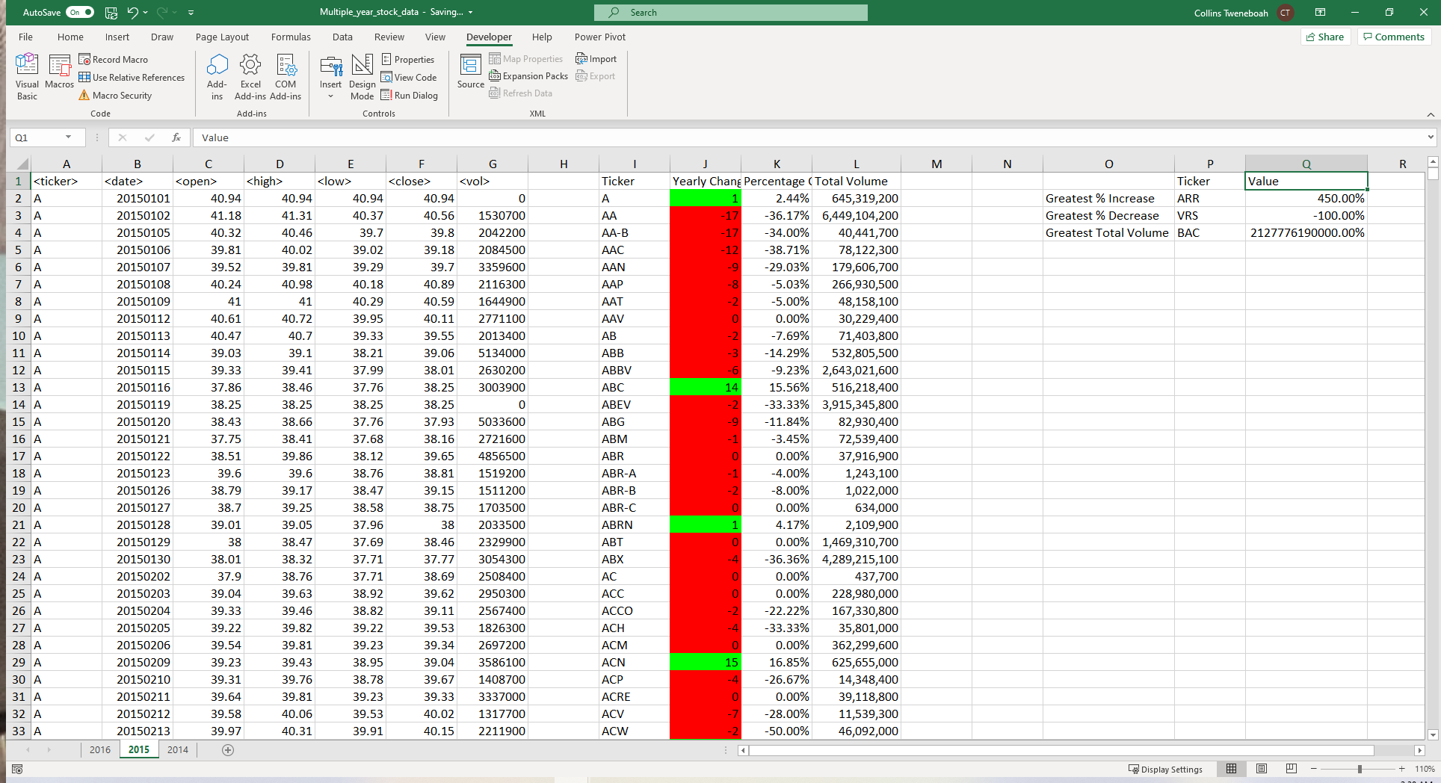

Worksheet 2015

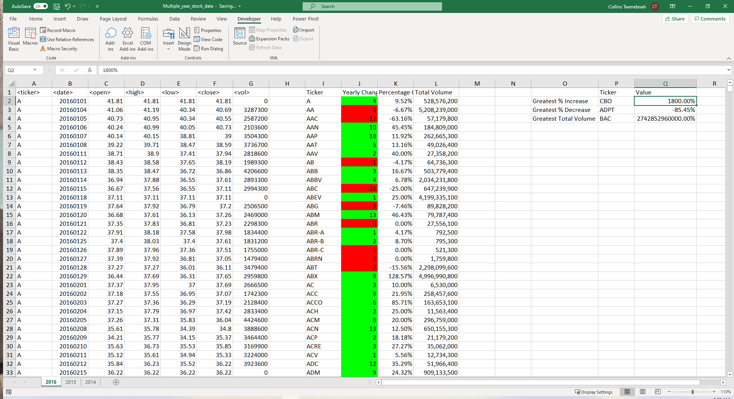

Worksheet 2016